Steps for Running Catchment Partition Code:

# Convert watershed grid (output of TauDEM StreamNet function) to shapefile:

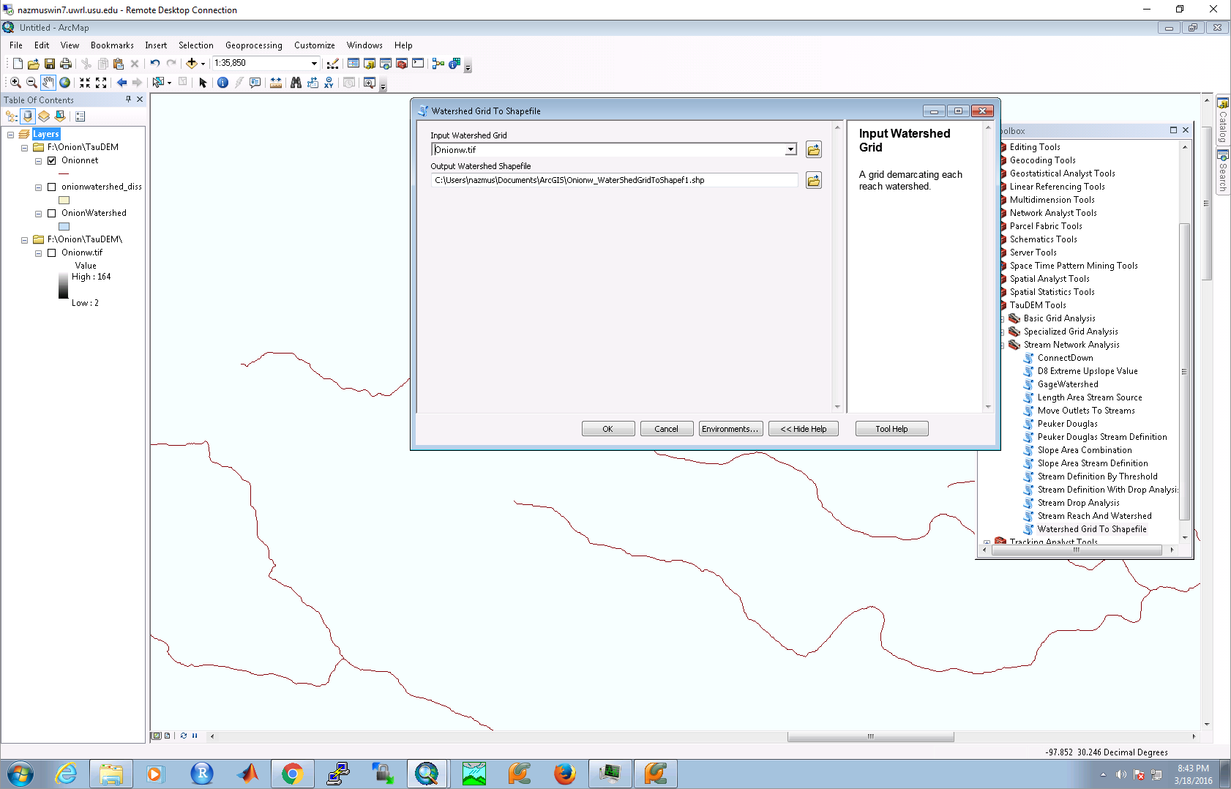

# Dissolve shapefile based on “GRIDCODE” attributes

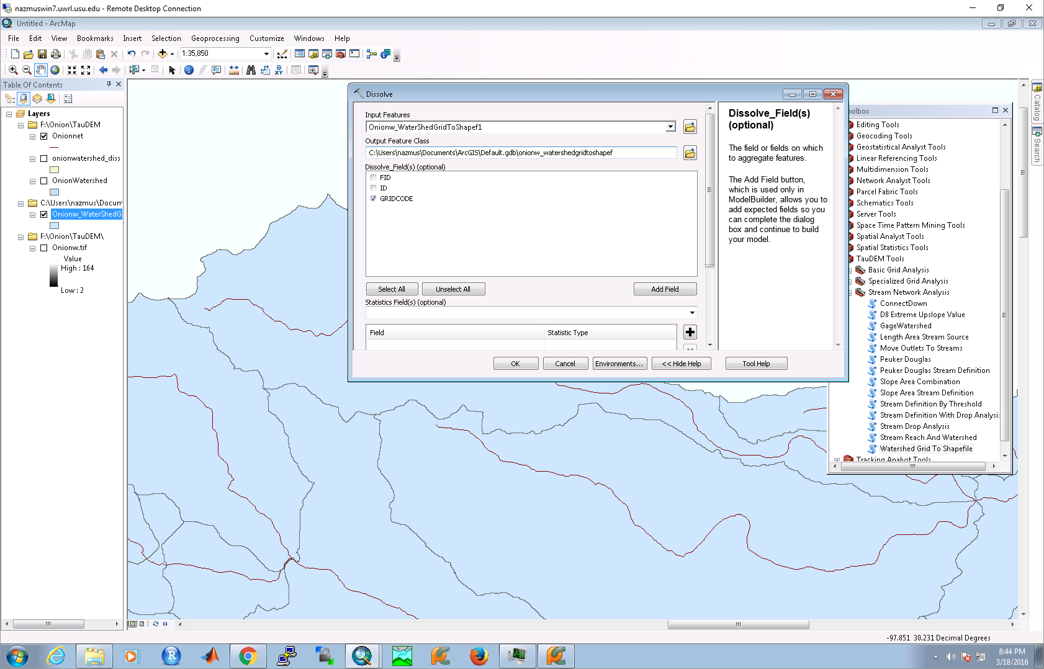

# Clone source code from Github

git clone https://github.com/nazmussazib/Flood_mapping_TauDEM

# Open project in PyCharm

You might get different project name

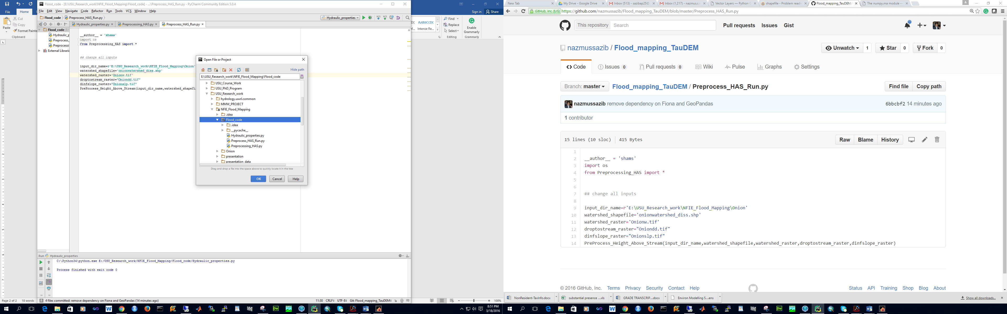

# Install necessary python package using Pycharm

Required python package:

1. GDAL
2. Pandas
3. numpy

# Change all inputs in Preprocess_HAS_Run.py and Run the code from PyCharm

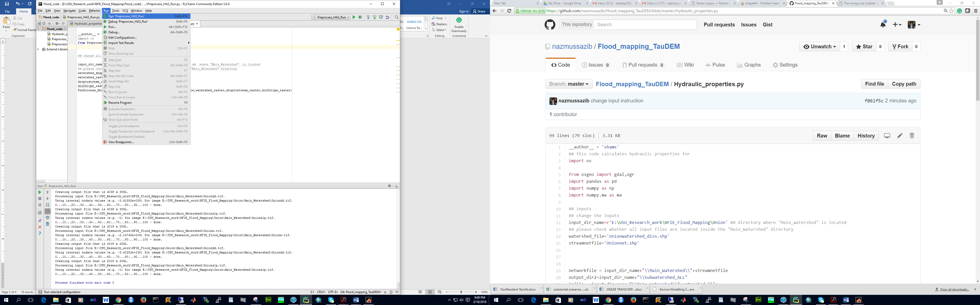

# Change all inputs in Hydraulic_properties.py and Run the code from PyCharm

